In the 1995 movie, *Die Hard: With A Vengeance*, John (Bruce Willis) and Zeus (Samuel Jackson) are being tormented by a villain, Simon Gruber (Jeremy Irons) who plants bombs around the city and poses riddles and puzzles for disarming them. In one situation, Simon gives them the following riddle to disarm a bomb at a fountain in a park:

*On the fountain there should be 2 jugs, do you see them? A 5-gallon and*

*a 3-gallon. Fill one of the jugs with exactly 4 gallons of water and place it*

*on the scale and the timer will stop. You must be precise; one ounce more*

*or less will result in detonation. If you’re still alive in 5 minutes, we’ll speak.*

Do John and Zeus survive? Of course they do! But can YOU solve their problem?

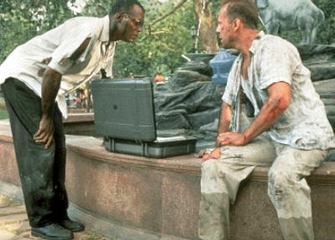 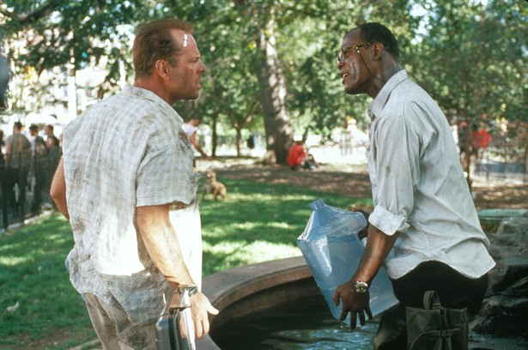

**Solution:** This is one way to do it: With both jugs empty, fill the 3-gallon jug full and pour it into the 5-gallon jug. Then fill up the 3-gallon jug again and pour it into the 5-gallon jug until it is full. Here is 1 gallon of water left in the 3-gallon jug, (3 + 3) – 5 = 1. Now empty the 5-gallon jug and pour in the 1 gallon from the 3-gallon jug. Fill up the 3-gallon jug again and pour it into the 5-gallon jug resulting in exactly 4 gallons of water in a 5-gallon jug, 1 + 3 = 4.

**A little math history:**

Math can be traced back as far as 3000 BC to Egypt and Babylonia. They developed math to help them solve problems. When they solved problems repeatedly, they formed a “recipe”.

If a method worked for one problem, then concluded that it might work for another similar problem, thus making a conjecture.

What is a **conjecture**? ________________________________________________________

___________________________________________________________________________

**Inductive Reasoning** _________________________________________________________

___________________________________________________________________________

We test conjectures or guesses by finding a _______________________ which means we find once example that proves our guess was false.

As time progressed, Greeks did not accept conjectures as the absolute truth, so they proved conclusion by using deductive reasoning. Then concepts were applied to problems resulting in structure, rules, and the logical development of mathematics.

**Deductive Reasoning** ________________________________________________________

Reasoning through a problem usually requires certain ________________. A _____________

can be an assumption, law, rule, etc. that is believed to be true, then logical conclusions follow.

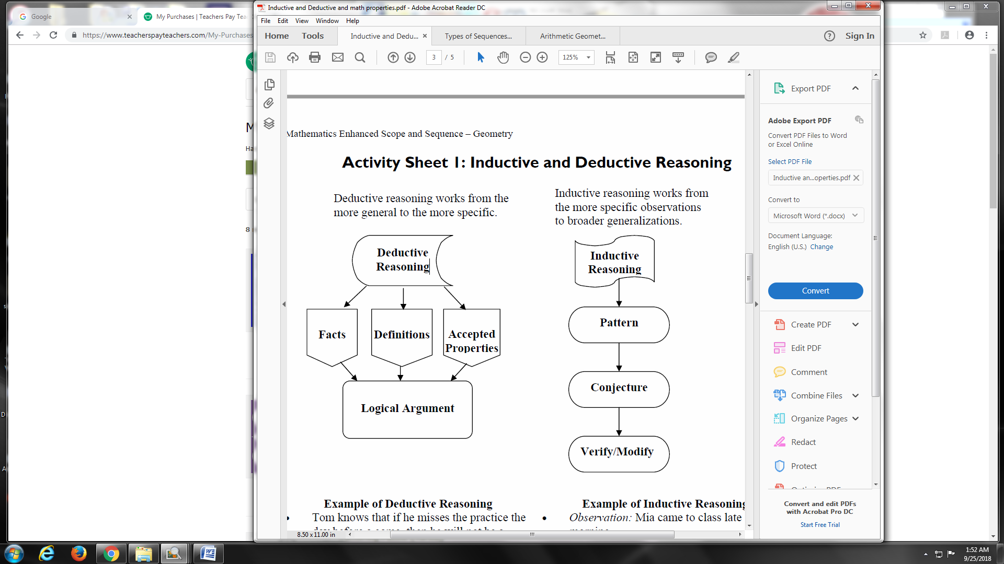

**EXAMPLES:** determine if the following statements are examples of inductive or deductive reasoning

1. It has rained every day for the past six days and it is raining today as well. So it will rain again tomorrow.

This is ___________________Why? ___________________________________________

1. Carrie’s first three children were boys. If she has another baby, it will be a boy.

This is ___________________Why? ___________________________________________

1. Finley had 85 baseball cards. His mom gave him 20 more for his birthday. Finley now has 105 cards.

This is ___________________Why? ___________________________________________

1. Doctors earn a lot of money. I want to earn a lot of money. I should become a doctor.

This is ___________________Why? ___________________________________________

1. What are the next two terms in the sequence? 5, 9, 13, 17, 21, 25, 29, _____ , _____

This is ___________________Why? ___________________________________________

1. What are the next two terms in the sequence? 2, 4, 8, 16, 32, _____ , _____

This is ___________________Why? ___________________________________________

1. What are the next two terms in the sequence? 1, 1, 2, 3, 5, 8, 13, 21, _____, _____

This is ___________________Why? ___________________________________________

1. How do you solve this problem? Solve the triangle for C.

c = ?

a = 3

b = 4

This is ___________________Why? ___________________________________________